Project 3000 Report
By NIKODEM DRABIK

Research

API

NEW
https://free-apis.github.io/#/categories

Website
WHOIS API – 500 free calls before I need to change key. No credit card required for this.
https://apilayer.com/marketplace/whois-api - free plan 3000 free requests
https://whoisjson.com – free 1000 monthly
https://docs.virustotal.com – not allowed commercially 500 per day
https://urlscan.io/live - not private high cost to expand
https://www.mywot.com/developers - costs
https://openphish.com/academic_use.html - open source community drive
https://urlhaus-api.abuse.ch – key generated check comp 3000
google api safe search
OpenPhish — phishing feed / intelligence. openphish.com
PhishTank — community-driven phishing URL data and API. (Often free). Reddit

Verify Email
https://cleantalk.org/blacklists
https://www.millionverifier.com/services/email-verifier-api
https://emaildetective.io/pricing -1000 emails per month
https://rapid-email-verifier.fly.dev/#/default/get_validate - free and open source
https://github.com/umuterturk/email-verifier

Issues
With this the issue I find is that all API keys are needed to be supplied by a user. Target market cannot do this themselves.
How do I ensure that they are supplying a valid key and how do I ensure that they are able to do so if they are meant to be tech illiterate? I do not have the scope to create my own for these two.

Languages/Technologies

Extension
JS
Chrome extension

Standalone App
C++ - main code
js – process data
Node.js – API

Gmail Add-on
Specifically integrates with Gmail mobile and desktop. Runs via google workspace add-on framework ad makes it easier to request OAuth and access Gmail API data.

Google Safe Browsing
Database of URLs that google constantly updates. A set of unsafe web pages or social engineering sites

Early Project Identification

Project Design

Version 1

Name
Phis-Knight.
Combination of Phishing and Knight. As a knight guards the people, and that is what I want it to be. And the name also allows me to have a theme for the software.

Style
I want to create a medieval colour scheme and medieval styled UI. So, it looks like a knight. I would like to create a mascot that is a knight that is the face of the app.

Elevator Pitch:
Phish-Knight a privacy first anti-phishing assistant. Detects phishing attempts and teaches you how to detect them.

Version 2

Name
Phish – Hussaria
A combination of Phishing and the abbreviation for the polish hussars. The hussars were European warriors coming out of Poland. As a result, I believe this would create a unique application design

Style
A pastel coloured designed very mellow colours that blend in on the screen and does not stand out.

Vision

Who?
The project is to be aimed at the elderly and young people. People that are tech-illiterate and as a result need assistant.

Why?
The main problem I want to solve is the large amount of phishing attacks on the vulnerable. According to the NCSC in a study in 2025 they effect 93% of business that were surveyed and 95% of charities that have been breached were accessed through this means.

The Product?
The project is to scan a screen and possibly screens HTML elements of a website and identifies the suspicious links and notifies the user.
I would like to also have the app to use a Language Model to analyse the email for possible Scam messages. A few flags:
- Generic and non-direct greetings like Ma’am, Sir, Mr
- Urgently wanting to redirect you.
- Sender’s address does not match the body or domain.

Reason For?
The reason for this approach Is this that I want to create a software that act like a trusted and tech literate grandson scanning a grandparent’s device for the same reason. I want software that also teaches the user of possible dangers and make them self-reliant.

Execution
At this stage I am unsure the type of software I will be creating. I have 3 possible ways to do this project. First being a standalone app that can download on the computer. The second being a browser extension that give much easier access to the browser data and manipulation of the data. But I believe for it to have less execution power. This led to the 3rd method which is a combination of both. Using the browser extension to harvest the required data and feed it into the app for processing and analysis.

Difference
Main part for this software is its trustworthiness. I want to create a software that has customisable intrusion settings. Based on how intrusive it will be, but less intrusive may mean less effective. However, this is a big part as it will hopefully make the user base more willing to use the software.
Secondly, I want this to be somewhat interactive where the user learns to seek the patterns the software is seeking for and hopefully learn to be independent.

Risks and Challenges
The phishing scams are one of the main approaches for attacks as a result they are often adapting to be more effective and finding innovative ways to find attack. This will be difficult to keep effective long term without constant modifications and a software that adapts and learns new patterns.

Personal Agenda.
I have a personal hatred for phishing scams aimed at the more vulnerable as it exploits the people that can’t defend themselves.

Risk Assessment
Risk | Likelihood | Impact | Mitigation/Response
Evolving Phishing Tactics | High | High | Software that can be easily maintained and updated to adapt to changes.
False Positives | High | High | Have a clear explanation for each flag. Provide methods to perform their own analysis if they disagree.
Data Privacy Concerns | High | Very High | Have all data processed locally where it is possible. If cloud services used or off device processing, use encrypted transmission and have a clear privacy policy
Challenges with integration | High | Medium | Start of with a small of integrated software and slowly expand the covered software.
Resource Constraints | Medium | High | Create a project schedule and keep to it. Prioritise core functions of the software. Seek feedback on development progress.
Legal Compliance and TOS | Low | High | Review GDPR and relevant regulations. Have a EULA and privacy agreement before using software.
Dependent API fail | Low | Very High | If a free and opensource API fails or stops working. Paid alternatives may be used incurring additional costs of the project and may result in an unaccounted cost for users
Misinterpretation of warnings | Low - Med | High | Use clear and non-technical vocabulary to explain warning. Possibly add More-info tab.
API limits | Medium | Very High | API calls may be limited due to not using enterprise level of software. This limits the total amount of calls I can perform daily. No Mitigation other than increasing plan at a higher cost
False Positives | Low | Very High | False positives may bring negative trust from the user for the app. However, only better algorithms can mitigate this issue.
GDPR infractions | Very Low | Very High | Ensure all data regarding users is explicitly explained in EULA minimise data used and stored.

Scope Restrictions MVP
- Works on Gmail. – 2nd most used email provider (second to apple ¼ of market according to litmus)
- Feedback to User regarding red flags identified
- Pop up mascot not animated
- User Feedback
- Intrusion Settings
- Some type of LLM
- English supported

LESP

Legal
Phish-Knight will comply with all relevant privacy and data protection laws specifically targeting GDPR.
Users must know exactly what data is being analysed, how the algorithm will be processing it, and for what purpose data is used. If AI is used it will be clearly explained including whether any user data is stored or used to train future models.
All data collection and processing will be disclosed in simple language, due to the target demographic, within the EULA and Terms of Service.
Third-party API terms will always be followed to prevent any breach of their usage policies.
False positives may occur, due to this the software will include disclaimers when positive flags are identified to make it clear that final judgement rests with the user. Phish-Knight cannot be held responsible for any damages caused by user decisions or undetected phishing attempts as the final verification must lay with the user.
Copyright and patent laws will also be respected.
The architecture should remain modular so that any non-compliant or region-restricted features can be disabled depending on local laws.

Ethical
Phish-Knight is built around respecting user autonomy. The user always remains in control meaning warnings can be ignored, and the reasons for flags will always be explained. This allows users to make informed choices instead of being forced into actions by the software.
The project’s purpose is to help and educate, not to scare or pressure people. Fear-based tactics will be avoided. Instead, Phish-Knight aims to build confidence and digital awareness by showing users how to recognise phishing attempts themselves.
The software will treat all users fairly, regardless of language, demographic, or background. No user should be disadvantaged by how information is presented. The software will attempt to represent all of the above.
Where possible, human in the loop feedback will be implemented, this will hopefully let users confirm or dispute detections to help the algorithms improve over time.
Transparency and honesty are key ethical goals. Nothing about the system’s AI or data handling should be hidden, misleading or ambiguous.

Social
Phish-Knight is aimed at both elderly and younger users, particularly those who are less confident with technology. The interface will use large, readable text, clear buttons, straightforward language and it intends to have playful characteristics for children and those with a sense of humour.
The design will be culturally sensitive avoiding any colours, icons, or text that could be inappropriate or exclusionary. The tone should always remain calm, friendly, and educational.
When the software detects something suspicious, it will explain why it was flagged and what to look for next time. The goal is to teach, not shame.
Users should never feel embarrassed for being targeted instead, the software should make them feel supported and more confident online.
Phish-Knight’s visual style and mascot (a knight styled character) can reinforce this idea of friendly protection something that watches over the user without taking away their control. The reason for a knight is due to the aura of safety.

Professional
The project will follow an Agile development process for flexibility and continuous improvement. This allows me to quickly adapt to new phishing methods and release regular patches for new attack vectors.
Testing will involve real users from the target audience to ensure accessibility, readability, and ease of use. Bug testing will be frequent, with detailed crash logs to speed up fixes.
Version control will separate test builds from stable releases to keep the project organised and prevent data loss.
All testing and analytical data will be clearly disclosed, with users knowing exactly what information is being collected and why.
The EULA and TOS will be written in simple, direct language so users can understand their rights, privacy protections, and data usage without needing legal expertise.

Market Solutions

Software

Avanan
A software that uses a cloud hosted email service. It evaluates existing relationships between senders and receivers to establish a level of trust. Additional It monitors Teams and Slack as they are emerging attack vectors.

Cofense PDR
Leverages AI tools and security professionals to identify and mitigate phishing attacks as they happen. They quarantine possible attacks. They also utilise global intelligence on what attacks worked and how to mitigate them

Mimecast
Several tools protect against phishing attempts. Such features detect suspicious links and redirects, attachments by removing them or rendering them safe via sandboxing. Mimecast prevents code-based attacks via sophisticated methods like QR-codes by opening them in the Mimecast cloud, this simplifies the deployment of their software and ensures prevention tools are always updated.

Extensions

PIXM phishing Protection
https://chromewebstore.google.com/detail/pixm-phishing-protection/flomofhkchlalfciiibgbfcpolhmglai
Uses AI to scan webpage for Logos and verifies if page is or is not owned by the stated website.

Anti Phishing
https://chromewebstore.google.com/detail/anti-phishing/npipcajipdkafdkellochifbfmppdalo
Warns when accessing blacklisted websites

Criminal IP: AI-based Phishing Link Checker
https://chromewebstore.google.com/detail/criminal-ip-ai-based-phis/dhkbjdnlhahnffncheehbnoaecncdpdk
Checks a link is malicious using who is and blocks access.

Blue Arca PhishGuard - Phishing Protection for WebMail
https://chromewebstore.google.com/detail/blue-arca-phishguard-phis/nbladngkelnbhcinepiogponadjggkcd
Web mail phishing detector. No idea how it works does not state or have video evidence.

Mascots

Clippit

A windows 97 Icon and mascot. Was designed to offer tips, provide shortcuts, and suggestions while user worked in office applications. Was a simple natural language processor to interpret user actions and provided context-based assistance.


BonziBuddy
BonziBuddy was a desktop assistant that could tell jokes, talk and sing songs. It aimed to make using the computer more fun by providing web browsing help. The program used text-to-speech technology for this.

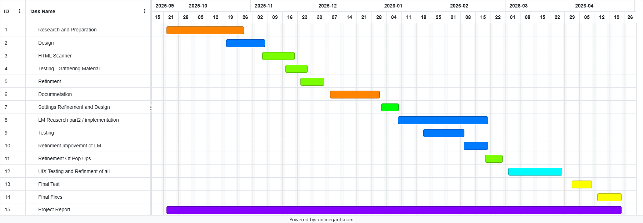

Gantt Chart
This is my initial Gant Chart for how long each stage may take. This may Change based on if task take faster or if I encounter Issues. I may also change the order of tasks based on what I see fit with further research and preparation.

Project Execution Plan

Objective
Develop Phish-Knight, a privacy-first Gmail add-on and/or Chrome extension that detects and explains phishing attempts to tech-illiterate users (especially elderly and younger users).
Core MVP Scope:
- Gmail integration (Add-on)
- Basic phishing detection (headers, links, sender)
- Educational feedback (explanation system)
- Mascot-based UI
- Adjustable Intrusion Settings

2. Approach
Agile development cycle short iterations, testing between phases, and continuous feature updates as phishing methods evolve. Each cycle no more than 3 weeks no less than 1 week

3. Tech Stack
Tools & Tech Stack:
- Frontend: Google Apps Script (for Add-on), HTML/CSS/JS (for Chrome extension UI)
- Backend: Node.js or Python Flask API for analysis and API calls
- APIs: Google Safe Browsing, OpenPhish, WHOIS API,
- LLM: a low intensity Llama model
- Version Control: GitHub + branches for stable/test builds
- Testing: Manual + user feedback

MVP Metrics
- 85%<= of phishing emails flagged in test data
- >= 10% of false positives
- User feedback 90%<= find explanation clear
- Deployable to Alpha Users.
- Works for English Emails

Post MVP Expansion
- Cross browser support
- Cross Email support
- Animated Mascot
- 99%<= accuracy
- Multi-Language Supported

Process Plan
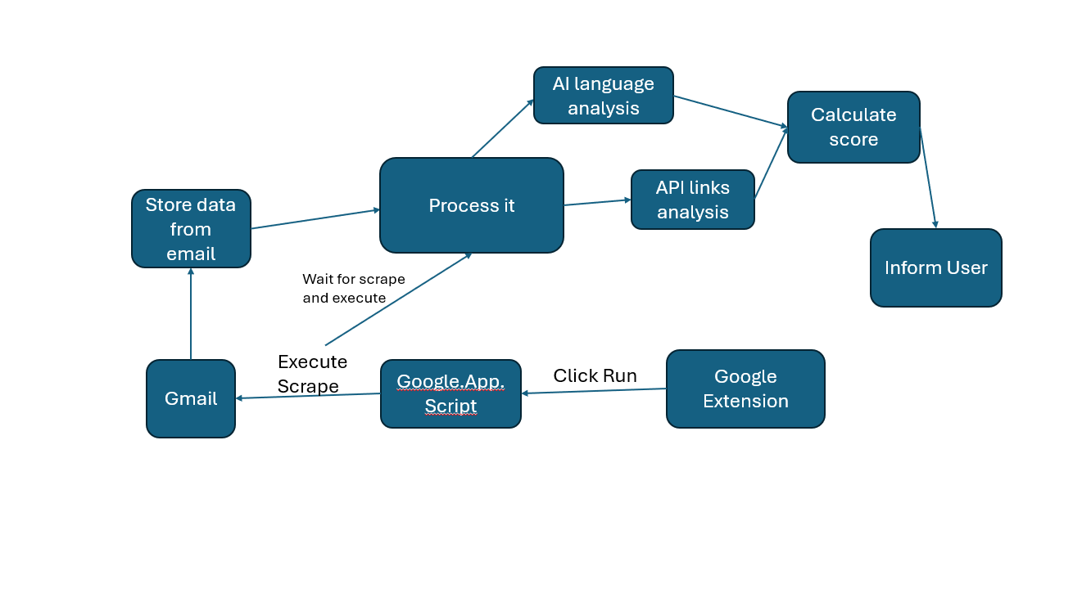
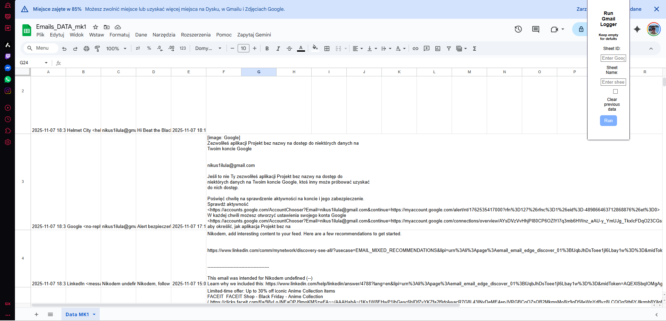

Tree walker
Why use TreeWalker instead of just innerHTML.replace()?
- Gmail emails have complex HTML structures, including links, formatting, signatures.
- innerHTML.replace() could accidentally break tags or formatting.
- TreeWalker ensures you only touch text, leaving all HTML intact.

FUTURE PLANNS

At this point I am scraping my own email.
In the future when I have bad words.json on an API I will have a running DB of data fall on that.

Reddit
- The manifest.json file. Every browser extension needs one of these and all the main building blocks of your extension will need to be listed here (e.g. html file for your extension/popup window, content script, service worker/background script etc.) This will also need to mention the Browser APIs you want your extension to be able to access.
- The content script (content.js/content.ts). This is the file that gets injected into the DOM that can actually alter stuff on the webpage (E.g. changing background colors).
- The background script/service worker (background.js/ts). Think of this as being like an event listener. There are a tonne of events that occur as a user browses the web (switching tab, going to a new website etc.). The background script can listen out for these events and then execute some code.
- Message passing. If your background script is listening out for events (such as a user going onto a specific website), it's going to need to pass a message to your content script. The content script will then execute some code to change the appearance of a webpage.
A good place to start learning these things is the Google Dev docs. In particular, if thinking about building a chrome extension, three very important APIs to look into would be the runtime, storage and tabs APIs. Since you've also mentioned that you want your extension to only work on a specific site, look into the webNavigation API too.
https://www.reddit.com/r/learnprogramming/comments/12gufle/making_a_chrome_extension_that_changes_the

Rory Meeting 20/11/25
Perform user testing early
Standardised Risk Assesment.
Gemini – seamless ai integration with google?

User Testing

User Bias
I will likely be using the same 3 users from the majority of my non-technical user tests (users with low technical knowledge). This may result in biased results due to them gaining more knowledge about the process as it goes on and near the end of the project they may be no longer “non-technical”. As a result, for final testing and later testing I will need to look to get more users to test.
I have access to multiple technical users from the university and I will use them to test the features to look for vulnerabilities and errors a non-technical user may not identify.

The users
User ID | Username | Unique Identity
User 1 | Aldona | Has limited knowledge of user interface.  Uses emails frequently at work.  Limited knowledge on Phishing scams and identifying factors
User 2 | Nicole | Some knowledge on phishing scams and technical ability.  Does not use emails for communication however uses for online stores and codes
User 3 | Marcin | Rarely uses emails other than for private official purposes and online shopping.  Limited knowledge on attacks
User 4 | Joe | Cyber Security Student.  Very Knowledgeable on the attacks and spotting attacks.
User 5 | Mark | Cyber Security Student.  Very Knowledgeable on the attacks and spotting attacks

Testing v1
I had my users my first working section of my initial prototype. I had the users test the UI for interacting with the software and tell me if the highlighting was identifiable.

Function | User 1 Feedback | User 2 Feedback | User 3 Feedback
Highlighted Words.  Criteria’s:  Visible  Understand the Use | Yes, its visible  After you explained, I will be able to spot it. | Visible  No issue | Maybe issue with darker/ red background  No issue
Press Highlight  Criteria’s:  Identify the button  Press the button | I can find the button without an issue.  No issue pressing the button. I like that it changes colour. | No issue  No issue | No issue
Additional comments not related to tests | I cover a lot of my screen | I like the logo.  maybe it’s too big? | Too much boxes that I don’t need. Blocks my vision of my email.

Testing Outcome
After this very short test of only my highlight function I received a little bit of feedback regarding my UI and with this, I will make the following changes and additional tests.
UI:
Make the UI see-through and smaller – after testing I cannot make it transparent
Make a dedicated Settings page for additional modifiers.
Hint Box may be required to explain usability

Highlight_Words:
Test with different backgrounds of text as red colour may affect it.

Testing action taken
After Looking at the comments, I went and noticed that it would be useful to also add a secondary section for Security Safety now, so the UI is ready for the future.
After the testing outcomes I went back to the design elements of my UI. My initial design had flaws and here are the steps I took to develop a better UI and improve the UX.

UI:
I made the UI smaller and relocated the additional settings to the to a separate tab that is a small cog.
I redesigned the sizing of sections so that the UI is more compact. The aim is that it will take up much less space than before
I made the red less of a dark red due to it making it difficult to see for the user. This may indicate that it was not visible to users with colour identification impairment specifically Protanopia (red colour deficient).
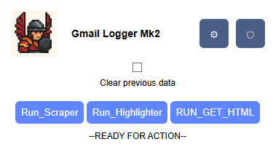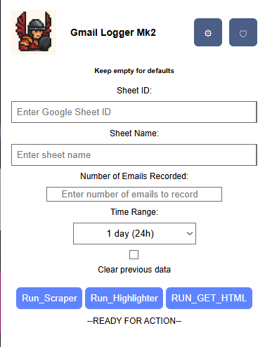

[rudimentary words highlighted for testing]

Challenges faced:
While developing the new UI I thought about making it see through to see what is behind the extension. However, after a few hours of research and trial and error of multiple ways identified on Stack overflow and other forums. I was unable to. The only reason I was able to identify is that the extension is its own “window” and it does not able to be made see through even with no background it stays opaque.
I plan on returning to this issue however the product functions and this can be a future project.

Look at ISO 27034 application security
https://github.com/funilrys/PyFunceble
https://github.com/Phishing-Database/Phishing.Database?tab=readme-ov-file – feed virus total

Virus total work

Access to fetch at 'https://www.virustotal.com/api/v3/domains/rutube.ru' from origin 'https://mail.google.com' has been blocked by CORS policy: Response to preflight request doesn't pass access control check: No 'Access-Control-Allow-Origin' header is present on the requested resource.

Emails
Phishing-1 : https://zenodo.org/records/13474746
Phisng-2 : https://www.kaggle.com/datasets/naserabdullahalam/phishing-email-dataset
Phishing-3 : https://www.kaggle.com/datasets/naserabdullahalam/phishing-email-dataset?select=phishing_email.csv – horrible not even English

Emails Linking to websites that are legit
Samle 408 from honey pot
https://www.linkedin.com/slink?code=gzq-mDRH?mwmw119300
Redirects to legit website to then re-direct again
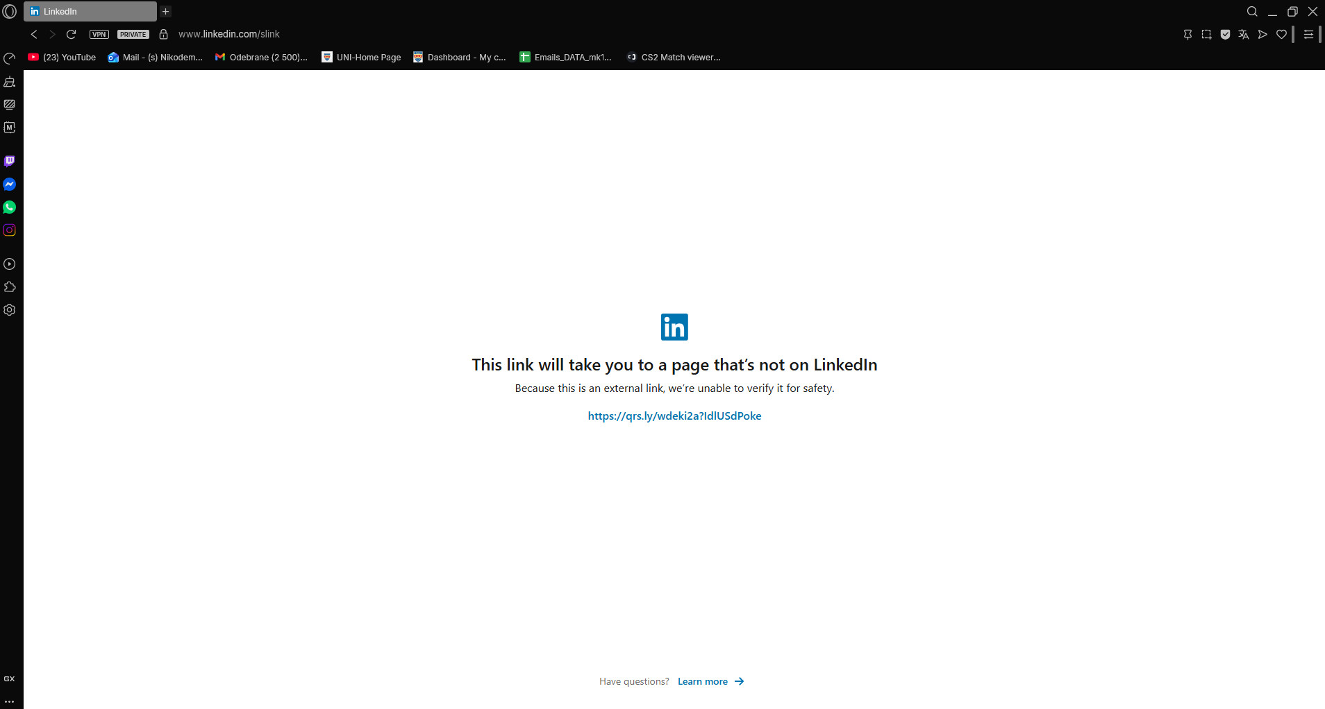
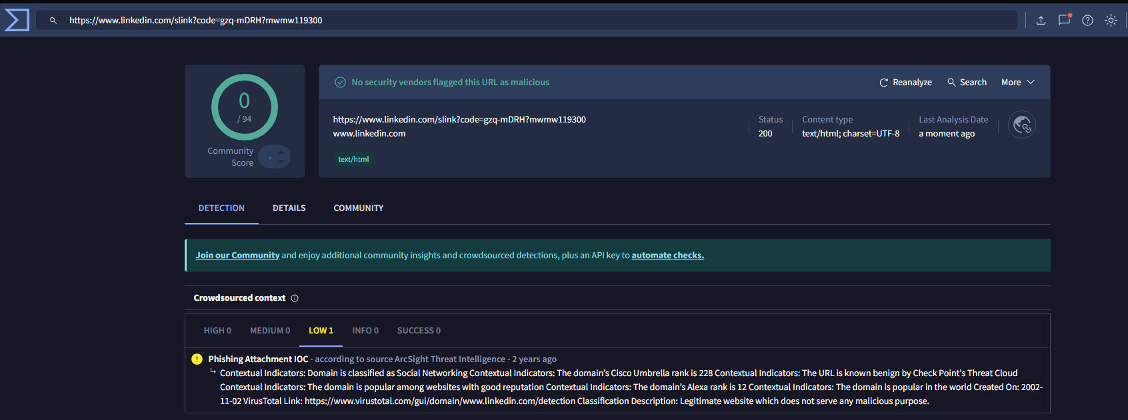

Extending the URL
https://github.com/Deadpool2000/Short-URL-Expander-API/blob/main/app.py
We need to have a quick look to see where a link lead too to make sure its safe.

